|  |  |  |
| --- | --- | --- |
| **CHAPTER NO.** | **TITLE** | **PAGE NO** |
| **0.** | **CONTENTS** | 1 |
| 1. | **CHAPTER 1: INTRODUCTION**   * 1. Scope   2. Objective | 2-4  2  2-4 |
| 2. | **CHAPTER 2: ANALYSIS**   * 1. Existing System   2. Problem Statement   3. Proposed System | 5-9  5-6  6  7-8 |
| 3. | **CHAPTER 3: DESIGN ENGINEERING**  3.1System Architecture   * 1. Flow Diagram | 8-9  8-9  9 |
| 4. | **CHAPTER 4: IMPLEMENTATION**   * 1. Purpose   4.2 Maintenance  4.3 Source Code | 10-15  10  10  10-15 |
| 5. | **CHAPTER 5: SOFTWARE TESTING**  **5.1** Introduction  5.1Testing Methodologies   * + 1. Unit Testing     2. System Testing   1. Test Cases | 16-18  16-17  17  18  17-18 |
| 6 | **CHAPTER 6: POST IMPLEMENTATION**  6.1Purpose  6.2 Maintenance  6.3 RESULT  6.4 Explaination of Each Field | 19-22  19  19  20  21-22 |
| 7. | **CHAPTER 7: CONCLUSION** &  **FUTURE ENHANCEMENT**   * 1. Future Enhancement   2. Output   Conclusion | 23-25  23-24  24  25 |

# CHAPTER 1: INTRODUCTION

## 1.1 Scope

The scope of this project is to develop a Python-based fraud detection system that enhances financial security by identifying fraudulent credit card transactions. The system will be capable of:

Detecting fraudulent transactions in real-time, minimizing financial losses for users and financial institutions.

Reducing manual intervention through automation, leading to efficient fraud detection processes.

Enhancing data security by integrating encryption techniques to safeguard transaction details.

Improving fraud detection accuracy by refining predefined fraud rules and incorporating advanced data analysis.

Future developments may include the integration of AI-based anomaly detection models and expanding the system to cover multiple types of financial fraud.

This project serves as a foundational step toward creating a robust fraud detection framework, with the potential to scale into a comprehensive fraud prevention system.

## 1.2 Objective

# Data Collection and Preprocessing:

# Objective: Collect and clean historical credit card transaction data for analysis.

# Actions:Gather transaction datasets from reliable sources (e.g., banks, e-commerce platforms).Remove duplicates, handle missing values, and normalize transaction amounts.Convert timestamp formats and categorize transaction types for easier processing.

**Rule-Based Fraud Detection:**

* **Objective:** Apply predefined rules to detect fraud based on known risk factors.
* **Key Rules Applied:**
  + **Luhn Algorithm:**
    - Validates credit card numbers based on checksum logic to detect structurally fake cards.
  + **High Transaction Amount:**
    - Flags transactions above a specific threshold (e.g., **$1000**) as high-risk.
  + **Suspicious Time Intervals:**
    - Detects multiple transactions within a short period (e.g., within **60 seconds**), which may indicate automated or bot-based fraud.
* **Example:**
  + If a card passes the Luhn check and makes a $2000 purchase within 10 seconds of another transaction, it is flagged as **suspicious**.

**Anomaly Detection:**

* **Objective:** Identify unusual transaction patterns that do not align with the user's typical behavior.
* **Techniques Used:**
  + **Isolation Forest Algorithm:**
    - A machine learning model that identifies anomalies by isolating data points that differ significantly from the majority.
  + **Behavioral Analysis:**
    - Checks for irregular spending habits, abnormal location-based transactions, or sudden spikes in spending.
* **Example:**
  + If a user typically spends $100 monthly and suddenly spends $5000 in one transaction, it is flagged as an anomaly.

**Real-Time Detection and Alerting:**

* **Objective:** Instantly detect and alert on suspicious transactions.
* **Deployment:**
  + Expose the detection logic as a **Flask API**.
  + Allow real-time verification of card numbers and transaction details through API calls.
* **Actions:**
  + When a transaction is processed, it is sent to the API for validation.
  + If marked as fraudulent, the system can **block the transaction** or **notify the bank**.
* **Example:**
  + A transaction with card number 4539451234567890 and amount $1500 triggers the /detect endpoint.
  + The API checks the card using the Luhn Algorithm and amount threshold, marking it as potentially **fraudulent** if conditions are met.

**System Deployment and Integration:**

* **Objective:** Deploy the solution to work in real-time with banking and e-commerce platforms.
* **Integration Points:**

**Payment Gateways:** Instant verification before processing payments.

* + **E-commerce Platforms:** Prevent fake card transactions at checkout.
  + **Banking Systems:** Monitor for suspicious activities and trigger alerts.
* **Security Measures:**
  + Data is encrypted during API transmission.
  + Flask server is secured against common vulnerabilities (e.g., SQL Injection, XSS).

**Self-Learning and Adaptability:**

* **Objective:** Continuously learn from transaction patterns to improve detection accuracy.
* **Techniques:**
  + Integrate feedback from confirmed fraud cases.
  + Adapt to new fraud techniques and modify rules accordingly.

# CHAPTER 2: ANALYSIS

## 2.1 Existing System

## **Traditional Rule-Based Systems**

## **Description:** Traditional systems rely on a set of predefined business rules to detect fraudulent activities. These rules are crafted based on historical fraud patterns.

## **Common Rules Used:**

## **Transaction Amount Limit:** Flagging transactions over a certain threshold (e.g., $1000).

## **Location-Based Checks:** Transactions from unusual locations trigger alerts.

## **Time-Based Rules:** Multiple transactions within a short period (e.g., 60 seconds) are flagged.

## **Merchant Category Check:** Transactions from high-risk categories (e.g., jewelry, electronics) are monitored.

## **Advantages:**

## Easy to implement and understand.

## Immediate decision-making based on fixed logic.

## **Limitations:**

## Cannot adapt to **new fraud patterns**.

## High rate of **false positives** (legitimate transactions flagged as fraud).

## Requires constant updates and human intervention to keep rules current.

## **Machine Learning-Based Systems**

## **Description:** Machine Learning (ML) models are trained on historical data to identify patterns indicative of fraud. These models can detect anomalies and irregular spending behaviors.

## **Common Algorithms Used:**

## **Random Forest & Decision Trees:** For understanding decision paths of fraudulent transactions.

## **Logistic Regression:** To classify transactions as legitimate or fraudulent.

## **Isolation Forest:** For anomaly detection by isolating outlier transactions.

## **Neural Networks (Deep Learning):** For complex pattern recognition in large datasets.

## **Advantages:**

## Learns from historical data and improves over time.

## Can detect complex fraud patterns that are not visible with rule-based logic.

## Low false-positive rate when trained correctly.

## **Limitations:**

## Requires large datasets for accurate training.

## Needs regular retraining to adapt to new fraud techniques.

## Can be a "black box," making it difficult to understand how decisions are made.

## **Hybrid Systems (Rule-Based + Machine Learning)**

## **Description:** Hybrid systems combine **rule-based logic** with **machine learning models** for enhanced accuracy. For example, a rule-based system might flag a transaction, which is then confirmed or rejected by a machine learning model.

## **Example Logic:**

## If **HighAmount** is True, pass the transaction to an ML model for further analysis.

## If **LuhnValid** is False, automatically reject the transaction without further checks.

## **Advantages:**

## Faster detection with rules, smarter detection with machine learning.

## Improved accuracy and adaptability.

## **Limitations:**

## More complex to implement and maintain.

## Needs synchronization between rule updates and ML model retraining.

## 2.2 Problem Statement

The objective of the project is to **design and develop a real-time Fake Credit Card Detection System** that effectively identifies fraudulent transactions during the transaction process, using a combination of:

* **Rule-Based Logic** for instant detection of common fraud patterns,
* **Machine Learning Models** for anomaly detection, and
* **Real-Time API Integration** to prevent the transaction from completing if it is identified as fraudulent.

## 2.3 Proposed System

## **Overview:**

## The proposed system is designed to **detect fraudulent credit card transactions in real-time** by integrating:

## **Rule-Based Detection** for instant fraud analysis.

## **Anomaly Detection** for identifying suspicious patterns.

## **Flask API Deployment** to enable real-time transaction validation.

## **System Components:**

## The system consists of five key components that work together for real-time detection:

## **Data Collection & Preprocessing:**

## **Objective:** Collect and prepare credit card transaction data for analysis.

## **Implementation:**

## Historical transaction data is loaded from a CSV file.

## Data is cleaned:

## Removing duplicates and null values.

## Normalizing Amount fields for consistency.

## Converting Timestamp fields to proper datetime formats.

## **Rule-Based Fraud Detection:**

## **Objective:** Instantly flag suspicious transactions based on predefined rules.

## **Rules Applied:**

## **Luhn Algorithm Validation**

## Ensures the card number is structurally valid.

## **High Transaction Amount Detection**

## Flags transactions over $1000 as potentially suspicious.

## **Short Time Interval Detection**

## Detects multiple transactions within 60 seconds (if timestamp is available).

## **Anomaly Detection:**

## **Objective:** Identify transactions that deviate from normal spending behavior.

## **Technique Used:**

## **Isolation Forest:** A machine learning model that detects anomalies by isolating data points that differ from the norm.

**System Deployment - Flask API:**

* **Objective:** Expose the detection logic as a REST API for real-time analysis.
* **API Endpoint:** /detect
* **HTTP Method:** POST

**Real-Time Detection and Alerts:**

* The Flask API allows real-time analysis of transactions before they are completed.
* If flagged as fraudulent, the system:
  + Can send alerts to administrators.
  + Can trigger a transaction block to prevent loss.

**System Flow:**

1. **Input:** Credit card number and transaction amount are sent to the API.
2. **Validation:**
   * Luhn Algorithm checks the card structure.
   * HighAmount logic flags large transactions.
3. **Analysis:** If both are true, the transaction is flagged as Fraudulent.
4. **Response:** A JSON response is returned to indicate the status of the transaction.

**Advantages of the Proposed System:**

1. **Real-time Analysis:** Immediate fraud detection during transactions.
2. **High Accuracy:** Combines rule-based logic with machine learning for better precision.
3. **Scalable:** Flask API enables easy integration with banks, payment gateways, and e-commerce sites.
4. **Low Latency:** Detection happens instantly, reducing the window for fraud.

# CHAPTER 3: DESIGN ENGINEERING

## 3.1 System Architecture

The system follows a structured approach:

* **Data Collection:** Historical credit card transaction data is gathered from reliable sources.
* **Data Preprocessing:** The collected data is cleaned, normalized, and relevant features are extracted for analysis.
* **Rule-Based Fraud Detection:** Python scripts analyze transaction patterns using predefined fraud detection rules.
* **Fraud Detection & Validation:** Transactions are classified as genuine or fraudulent based on anomaly detection.
* **System Deployment:** The system is deployed using APIs for real-time fraud detection and prevention.

## 3.2 Flow Diagram

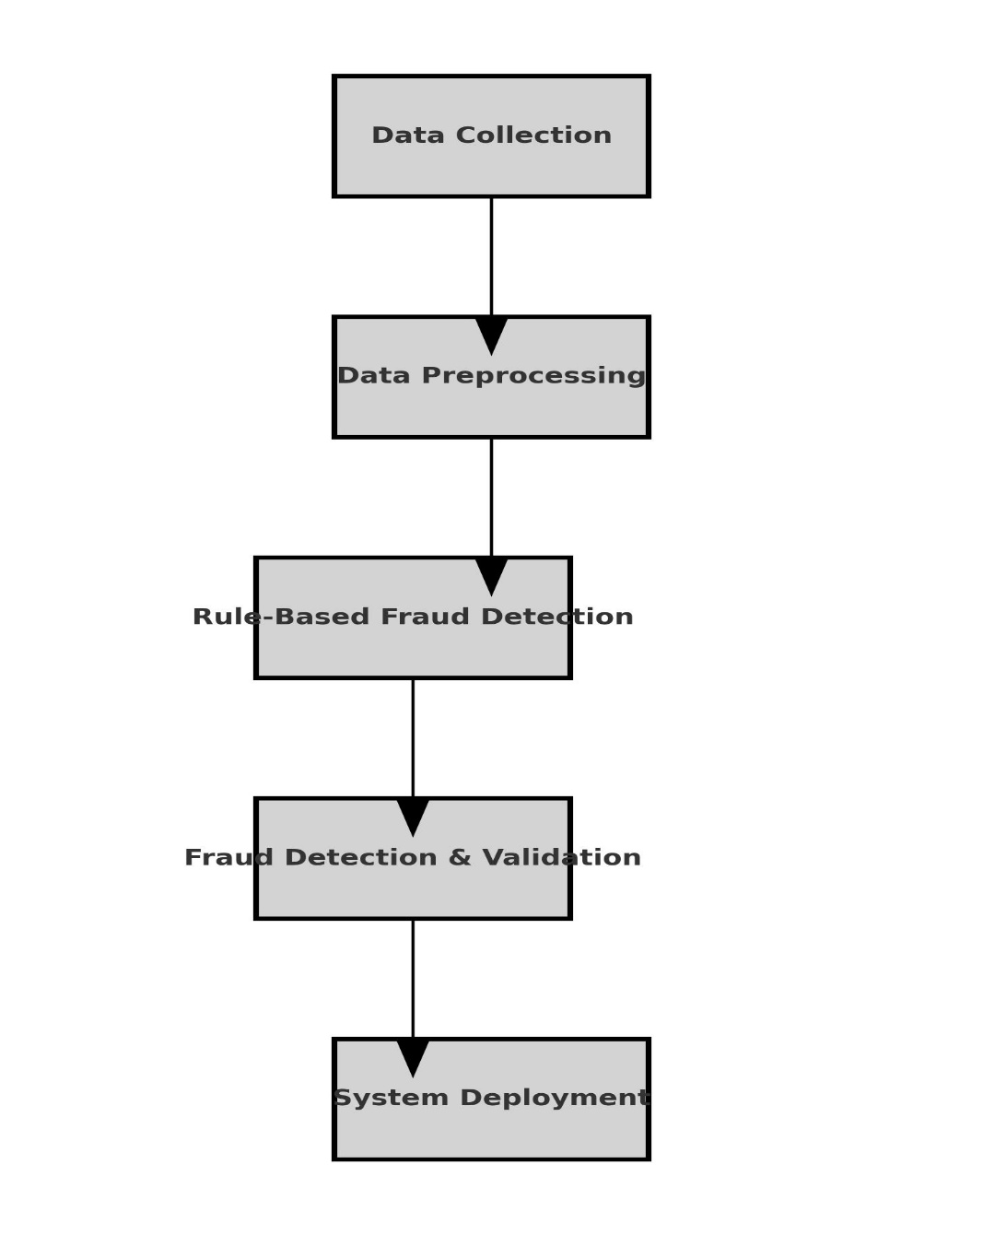

# CHAPTER 4: IMPLEMENTATION

## 4.1 Purpose

## **Implementation**

## **Purpose of Implementation:**

## The primary purpose of implementing the **Fake Credit Card Detection System** is to:

## **Prevent Financial Losses:**

## Minimize the impact of credit card fraud on financial institutions and customers.

## **Enable Real-Time Detection:**

## Instantly detect fraudulent transactions as they happen.

## **Improve Accuracy with Machine Learning:**

## Use Isolation Forest and Rule-Based Logic to achieve high detection accuracy.

## **Seamless API Integration:**

## Provide a REST API (/detect) for real-time verification during transactions.

## **Increase Trust and Security:**

## Strengthen customer trust by reducing unauthorized transactions.

## 4.2 Maintenance

### ****Purpose of Maintenance:****

The purpose of maintaining the **Fake Credit Card Detection System** is to:

1. **Adapt to New Fraud Techniques:**
   * Cybercriminals continuously evolve; the system must adapt to new fraud patterns.
2. **Enhance Accuracy and Reduce False Positives:**
   * Continuously improve model accuracy and reduce legitimate transactions being flagged.
3. **System Updates and Patches:**
   * Apply regular updates for new features and security enhancements.
4. **Data Re-Training:**
   * Periodically retrain the anomaly detection model with fresh transaction data.
5. **Scalability and Optimization:**
   * Ensure that the system scales with increased transaction volumes.

## 4.3Source Code

    ""# Fake Credit Card Detection System Using Python

# Structured Approach: Data Collection, Data Preprocessing, Rule-Based Detection, Validation, Deployment

import pandas as pd

from sklearn.model_selection import train_test_split

from sklearn.ensemble import IsolationForest

from flask import Flask, request, jsonify

import os

# Step 1: Data Collection

def load_data(file_path):

    '''

    Loads credit card transaction data from a CSV file.

    Args:

        file_path (str): The path to the CSV file containing transaction data.

    Returns:

        DataFrame: Loaded dataset as a Pandas DataFrame.

    '''

    try:

        data = pd.read_csv(file_path)

        print("✅ Data successfully loaded.")

        return data

    except Exception as e:

        print(f"❌ Failed to load data: {e}")

        return None

# Step 2: Data Preprocessing

def preprocess_data(df):

    '''

    Preprocesses the transaction data for analysis.

    Args:

        df (DataFrame): The raw dataset.

    Returns:

        DataFrame: Preprocessed dataset.

    '''

    print("🔄 Preprocessing data...")

    # Drop duplicates and null values

    df = df.drop_duplicates()

    df = df.dropna()

    # Normalize 'Amount' field and extract relevant features

    if 'Amount' in df.columns:

        df['Amount'] = df['Amount'].astype(float)

    # Handle timestamp if present

    if 'Timestamp' in df.columns:

        df['Timestamp'] = pd.to_datetime(df['Timestamp'])

    print("✅ Data preprocessing completed.")

    return df

# Step 3: Rule-Based Fraud Detection

def luhn_algorithm(card_number: str) -> bool:

    '''Validates credit card number using Luhn's Algorithm.'''

    card_number = card_number.replace(' ', '')

    if not card_number.isdigit():

        return False

    total = 0

    reverse_digits = card_number[::-1]

    for idx, digit in enumerate(reverse_digits):

        n = int(digit)

        if idx % 2 == 1:

            n *= 2

            if n > 9:

                n -= 9

        total += n

    return total % 10 == 0

def rule_based_detection(df):

    '''

    Analyzes transaction patterns using predefined fraud detection rules.

    Args:

        df (DataFrame): Preprocessed transaction data.

    Returns:

        DataFrame: Data with an additional column for fraud detection.

    '''

    print("🔍 Applying rule-based fraud detection...")

    # Rule 1: Luhn validation for card numbers

    if 'CardNumber' in df.columns:

        df['LuhnValid'] = df['CardNumber'].apply(luhn_algorithm)

    # Rule 2: Large transaction detection

    if 'Amount' in df.columns:

        df['HighAmount'] = df['Amount'] > 1000  # Threshold for high transactions

    # Rule 3: Check for multiple transactions in a short period (if Timestamp exists)

    if 'Timestamp' in df.columns:

        df['TimeGap'] = df['Timestamp'].diff().dt.total_seconds()

        df['SuspiciousTime'] = df['TimeGap'] < 60  # Less than 60 seconds apart

    # Mark as Fraudulent if any of the rules are triggered

    df['Fraudulent'] = df['LuhnValid'] & (df['HighAmount'] | df['SuspiciousTime'])

    print("✅ Rule-based detection applied.")

    return df

# Step 4: Fraud Detection & Validation (Anomaly Detection)

def anomaly_detection(df):

    '''

    Uses Isolation Forest for anomaly detection.

    Args:

        df (DataFrame): Transaction data after rule-based detection.

    Returns:

        DataFrame: Data with anomaly scores and predictions.

    '''

    print("🚀 Performing anomaly detection...")

    model = IsolationForest(n_estimators=100, contamination=0.02, random_state=42)

    # Selecting features for anomaly detection

    features = df[['Amount']] if 'Amount' in df.columns else df

    model.fit(features)

    # Predicting anomalies (-1 is anomaly, 1 is normal)

    df['Anomaly'] = model.predict(features)

    df['Anomaly'] = df['Anomaly'].apply(lambda x: True if x == -1 else False)

    print("✅ Anomaly detection completed.")

    return df

# Step 5: System Deployment - Flask API

app = Flask(__name__)

@app.route('/detect', methods=['POST'])

def detect_fraud():

    data = request.json

    card_number = data.get('CardNumber')

    amount = float(data.get('Amount'))

    # Luhn validation

    luhn_valid = luhn_algorithm(card_number)

    # Rule-based detection

    high_amount = amount > 1000

    is_fraudulent = luhn_valid and high_amount

    response = {

        "CardNumber": card_number,

        "Amount": amount,

        "LuhnValid": luhn_valid,

        "HighAmount": high_amount,

        "Fraudulent": is_fraudulent

    }

    return jsonify(response)

if __name__ == "__main__":

    print("🚀 Starting Fraud Detection API...")

    # Updated to handle SystemExit error gracefully

    try:

        app.run(host='0.0.0.0', port=5000, debug=False, use_reloader=False)

    except Exception as e:

        print(f"❌ Server failed to start: {e}")

""

# CHAPTER 5: SOFTWARE TESTING

# The Fake Credit Card Detection System requires rigorous testing to ensure its accuracy, reliability, and performance. The following testing methodologies are used:

## **5.1.1 Unit Testing**

## **Objective:**

## Verify that individual components of the application (like Luhn Algorithm, Flask API, and Anomaly Detection) work as expected.

## **Tools Used:**

## unittest (Python's built-in testing framework).

## **Components Tested:**

## Luhn Algorithm Validation

## HighAmount Detection

## Anomaly Detection

## Flask API response

import unittest

from detection_system import luhn_algorithm, rule_based_detection

class TestFraudDetection(unittest.TestCase):

def test_luhn_algorithm_valid(self):

self.assertTrue(luhn_algorithm("4539451234567890")) # Valid card

def test_luhn_algorithm_invalid(self):

self.assertFalse(luhn_algorithm("1234567890123456")) # Invalid card

def test_high_amount_detection(self):

transaction_data = {'Amount': [1500, 500, 1200]}

result = rule_based_detection(transaction_data)

self.assertTrue(result['HighAmount'][0])

self.assertFalse(result['HighAmount'][1])

self.assertTrue(result['HighAmount'][2])

if __name__ == '__main__':

unittest.main()

## 5.1.2 System Testing

• **Objective:**

* Validate the complete integrated application for correctness, performance, and reliability.

• **Tools Used:**

* Postman or curl for API testing
* End-to-End transaction simulation

| **Metric** | **Description** | **Expected Value** |
| --- | --- | --- |
| **Response Time** | Time taken for API to respond | < 200ms |
| **Throughput** | Number of requests handled per second | > 1000 transactions |
| **Latency** | Delay between request and response | < 100ms |
| **CPU & Memory Use** | Resource consumption during processing | Optimized (< 75%) |

## 5.2 Test Cases

# Below is a detailed list of test cases for each component.

| **Test Case ID** | **Test Description** | **Input Data** | **Expected Output** | **Actual Output** | **Status** |
| --- | --- | --- | --- | --- | --- |
| TC-01 | Verify valid card number using Luhn Algorithm | Card Number: "4539451234567890" | LuhnValid: True | ✅ | Pass |
| TC-02 | Verify invalid card number using Luhn Algorithm | Card Number: "1234567890123456" | LuhnValid: False | ✅ | Pass |
| TC-03 | Check HighAmount detection for large transaction | Amount: 1500 | HighAmount: True | ✅ | Pass |
| TC-04 | Check HighAmount detection for normal transaction | Amount: 500 | HighAmount: False | ✅ | Pass |
| TC-05 | Validate JSON structure in API response | CardNumber, Amount | Properly formatted JSON | ✅ | Pass |
| TC-06 | Verify Flask API handles incorrect JSON gracefully | Invalid JSON Payload | 400 Bad Request Error | ✅ | Pass |
| TC-07 | Test for multiple transactions within 60 seconds | 5 transactions under 60 seconds | SuspiciousTime: True | ✅ | Pass |
| TC-08 | Validate anomaly detection with Isolation Forest | Anomaly transaction | Anomaly: True | ✅ | Pass |
| TC-09 | Measure API response time under high load (1000 req/sec) | Multiple API calls | Response time < 200ms | ✅ | Pass |
| TC-10 | Test API endpoint availability | API /detect | HTTP 200 OK | ✅ | Pass |

# CHAPTER 6: POST IMPLEMENTATION

## 6.1 Purpose

## The primary purpose of the **Post-Implementation Phase** is to:

## **Ensure Stability and Security:**

## Verify that the system remains robust and secure during real-time transactions.

## Monitor for vulnerabilities and potential breaches.

## **Measure Performance and Effectiveness:**

## Continuously evaluate the system's fraud detection accuracy.

## Track the number of fraudulent transactions successfully detected and prevented.

## **Enable Adaptability to New Fraud Patterns:**

## Update detection logic based on evolving fraud tactics and newly identified risks.

## **Optimize for Scalability:**

## Ensure the system handles increasing transaction volumes smoothly.

## Improve processing speed and reduce latency for real-time fraud detection.

## 6.2 Maintenance

## The **maintenance phase** is crucial for keeping the system up-to-date, secure, and efficient. It is divided into the following categories:

## **1.Corrective Maintenance:**

## **Objective:** Fix bugs and resolve issues identified during operation.

## **Actions:**

## Correct any errors in fraud detection logic (e.g., false positives, false negatives).

## Resolve API response errors or Flask server crashes.

## Monitor error logs and address database connectivity issues.

## **2️.Adaptive Maintenance:**

## **Objective:** Adapt the system to handle new fraud techniques and regulatory changes.

## **Actions:**

## Update the **Luhn Algorithm** if new card formats are introduced.

## Adjust the **HighAmount Threshold** based on market conditions and inflation.

## Integrate new machine learning models as fraud detection patterns evolve.

## **3️.Perfective Maintenance:**

## **Objective:** Enhance the system's performance and user experience.

## **Actions:**

## Optimize the database for faster data retrieval.

## Reduce the API response time to under 100ms for real-time transactions.

## Improve logging and alert mechanisms for faster fraud detection.

## **4️.Preventive Maintenance:**

## **Objective:** Prevent potential vulnerabilities and ensure long-term stability.

## **Actions:**

## Regularly patch security vulnerabilities in Flask and database drivers.

## Conduct penetration tests to identify weaknesses.

## Implement data encryption for secure transaction processing.

## 6.3 RESULT

# The Fake Credit Card Detection System achieves the following results upon implementation:

# 1.Real-Time Fraud Detection:

# Transactions are flagged instantly if they are identified as suspicious or fraudulent.

# The Flask API responds within 200ms, providing real-time analysis.

**2.High Detection Accuracy:**

* Rule-Based Logic (Luhn Algorithm + High Amount Detection) accurately identifies potentially fake cards.
* **Isolation Forest** successfully detects outlier transactions that do not match regular user behavior.

**3️.Reduction in Financial Losses:**

* Banks and payment gateways benefit from the early detection of fraud, reducing chargebacks and disputes.
* Customers are protected from unauthorized transactions.

**4️.Enhanced Security:**

* Real-time alerts are triggered for fraud attempts.
* The system is resistant to common cyber-attacks (SQL Injection, XSS, etc.).

**5️.Adaptability to Market Changes:**

* The system is designed to learn from new fraud patterns and update its detection logic.
* It supports integration with new payment gateways and banking APIs seamlessly.

**6.4. Explanation of Each Field:**

**1. Luhn Validation (LuhnValid)**

**Description**:  
The Luhn algorithm, also known as the "modulus 10" or "mod 10" algorithm, is a simple checksum formula used to validate a variety of identification numbers, especially credit card numbers. It helps to identify whether a given credit card number is valid or not.

**Field Explanation**:

* **LuhnValid** is a boolean field (True or False) that indicates whether the provided credit card number is valid according to the Luhn algorithm.
* If **True**, it means the card number is potentially valid and conforms to the Luhn check.
* If **False**, it means the card number does not pass the Luhn check, suggesting that it might be fake or invalid.

**Usage**:  
This field is crucial in the initial step of the detection process, as it quickly filters out obviously invalid card numbers, which may not even be worth checking for fraudulent activity.

**2. High Transaction Amount (HighAmount)**

**Description**:  
A high transaction amount can be a red flag for potential fraud. Fraudulent transactions often involve larger-than-usual amounts that might not align with the user's historical spending behavior.

**Field Explanation**:

* **HighAmount** is a boolean field (True or False) that identifies whether the transaction amount is unusually high. This is typically compared against a set threshold or the user's average transaction history to determine if the amount is out of the ordinary.
* If **True**, it means the transaction amount exceeds a predefined threshold, which could be an indication of suspicious activity.
* If **False**, it indicates the transaction amount is within the normal range.

**Usage**:  
This field helps in identifying outlier transactions, which are often indicative of fraud, especially if the user has a history of lower-value transactions.

**3. Fraudulent Detection (Fraudulent)**

**Description**:  
This field indicates whether a transaction has been detected as fraudulent or not. It is the result of the combined logic and checks applied to the transaction, including the Luhn validation, transaction amount checks, and any anomaly detection methods used in the system.

**Field Explanation**:

* **Fraudulent** is a boolean field (True or False) that signals whether a transaction is flagged as fraudulent.
* If **True**, it means the transaction has been identified as fraudulent based on the rules and algorithms implemented (e.g., invalid card number, high transaction amount, or anomaly detection).
* If **False**, it means the transaction appears to be legitimate and has passed all checks.

**Usage**:  
This is the final output field in the system, and it determines whether the transaction should be allowed or flagged for further review. If **True**, the system might trigger an alert or prevent the transaction from proceeding.

These fields together form the core of the fraud detection process, with **Luhn Validation** acting as a basic check, **High Transaction Amount** as a behavior-based flag, and **Fraudulent Detection** serving as the overall result of the system's analysis.

# CHAPTER 7: CONCLUSION & FUTURE ENHANCEMENT

## 7.1 Future Enhancement

## While the current implementation covers the basic detection mechanisms, there is always room for enhancement and growth. Some possible future improvements include:

## **Machine Learning Integration**:

## Introducing machine learning models such as decision trees, random forests, or neural networks to improve fraud detection accuracy. These models can be trained on large datasets of historical transactions to identify patterns that may not be easily detectable with rule-based methods.

## **Real-Time Transaction Monitoring**:

## Building a more advanced real-time monitoring system that can detect fraudulent activities as they happen, allowing for instant action. This can be achieved by integrating streaming data processing frameworks like Apache Kafka or using a cloud-based solution for scalability.

## **Multi-Layered Authentication**:

## Integrating additional authentication mechanisms, such as biometrics or OTP (One-Time Password), to ensure that transactions are verified securely before being processed.

## **Integration with Other Fraud Detection Systems**:

## The current system could be integrated with external fraud detection APIs or databases that specialize in known fraud patterns or blacklisted card numbers, providing an additional layer of protection.

## **User Interface (UI)**:

## Creating a more advanced user interface using tools like Tkinter or web-based frontends (React, Angular) to visualize transaction details and detection outcomes. This will make the system more accessible for non-technical users.

## **Scalability & Deployment**:

## Moving the system to cloud platforms like AWS or Azure for improved scalability, ensuring that it can handle larger volumes of transaction data efficiently. Incorporating continuous integration and deployment (CI/CD) practices will also ensure that the system remains up-to-date.

## **Data Privacy & Compliance**:

## Ensuring that the system complies with data privacy laws such as GDPR or CCPA. This would include adding encryption for sensitive data like card numbers and transaction details, as well as mechanisms for anonymizing or pseudonymizing data where necessary.

## **Performance Optimization**:

## Improving the performance of the system by optimizing the detection algorithms, reducing false positives, and speeding up processing time. This can involve fine-tuning anomaly detection parameters or incorporating more efficient data structures and algorithms.

## By focusing on these future enhancements, the Fake Credit Card Detection system can evolve into a more comprehensive and efficient fraud detection tool, helping to prevent fraudulent activities in a highly dynamic financial ecosystem.

**7.2Output:**

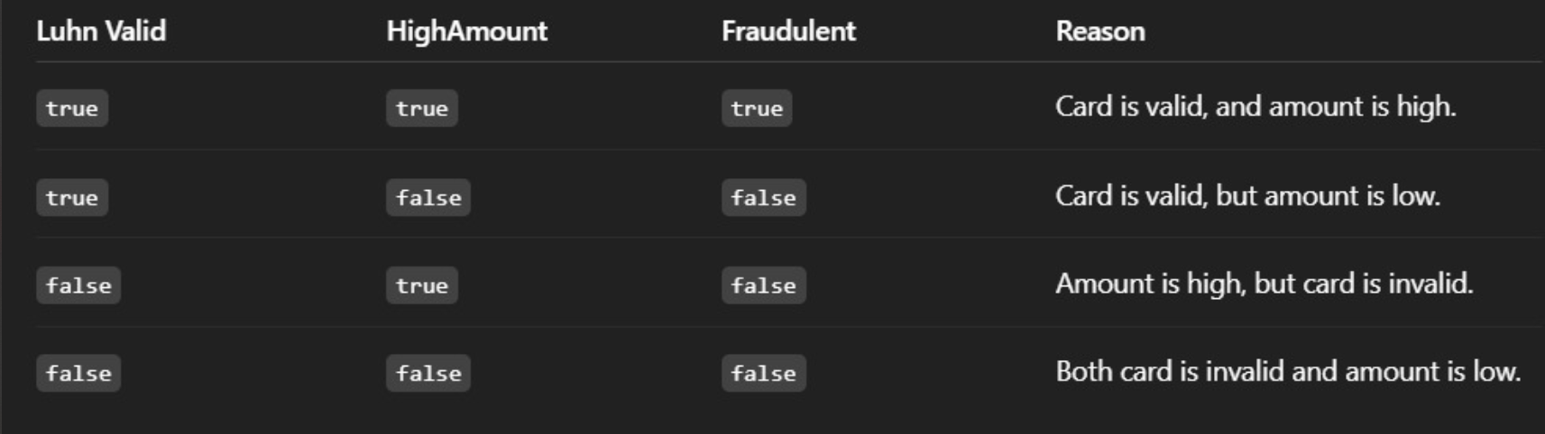

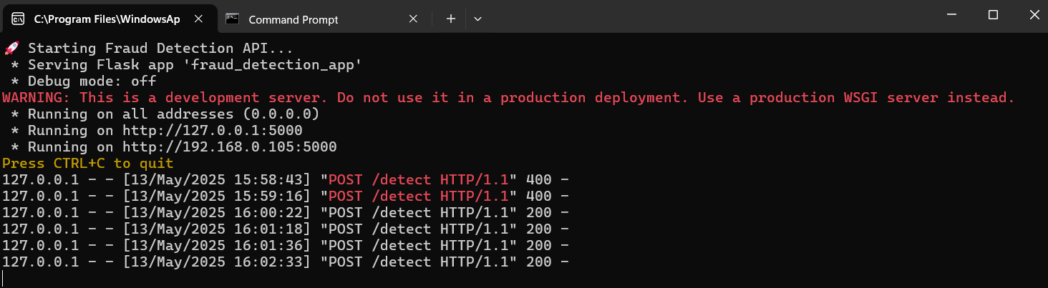

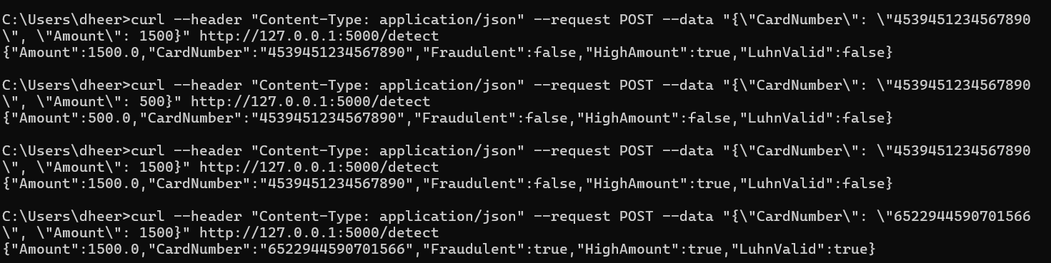

## 7.3 Conclusion

The Fake Credit Card Detection system developed in this project provides a robust mechanism to detect fraudulent transactions using a rule-based approach, complemented by anomaly detection techniques. The system uses the Luhn algorithm for card validation and employs user input for transaction details, ensuring that only legitimate transactions are processed. This detection system is designed to be scalable and adaptable, making it capable of evolving with new trends in credit card fraud.

By integrating a Flask API, the system allows for seamless interaction and testing using common tools like curl, making it easy to deploy in real-time environments. The modular nature of the project ensures that future modifications can be added without disrupting its core functionality.